Cloud Identity and Access Management Architecture documentation
This Identity and Access Management (IAM) architecture project was designed to build hands-on experience with Microsoft Entra ID and core enterprise identity concepts, including user lifecycle management, role-based access control (RBAC), and application access assignment.
The initial objective of the project was to simulate a mid-sized enterprise environment by creating:
- 25 user accounts
- 10 security groups (RBAC roles)
- Multiple enterprise applications with controlled access assignments
Architecture:
This architecture was designed to simulate a mid-sized enterprise Identity and Access Management (IAM) environment using Microsoft Entra ID. The implementation focuses on core IAM principles including user lifecycle management, role-based access control (RBAC), group-based access assignments, enterprise application integration, and multi-factor authentication (MFA). The environment provides a structured identity model that demonstrates how users, groups, and applications can be managed securely and efficiently within a centralized cloud identity platform. 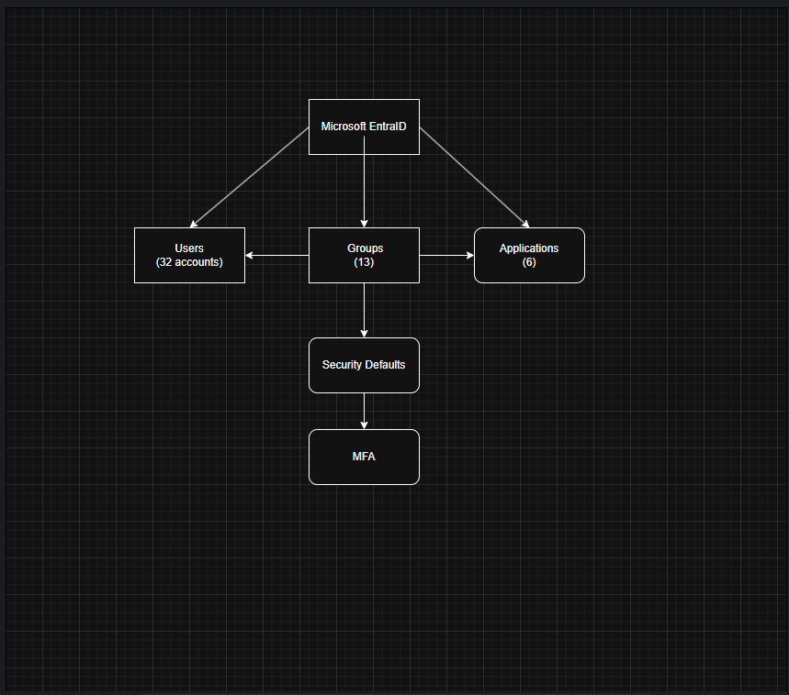

Users:
The 32 user Accounts represent employees across the multiple departments and business. These accounts are to simulate a enterprise level environment to support the testing of role-based access control (RBAC) group memberships, and application access assignments within Microsoft Entra ID.

Toby_Flenderson | Holly_Flax
Karen_Stafford | Angela_Martin | April Ludgate
Andrew_Dwyer | Ron_Swanson | Todd_Barkley
Tyler_Burke | Ted_Mosby | Jake_Peralta
Jean_Ralphio | Terry_Jeffords | Adrian_Pimento
Ryan_Howard | Pam_Beesley | Doug_Judy
Jerry_Gregich | Garry_Gregich | Charles_Doyle
Chris_Traegar | Ben_Wyatt | Micheal_Scott
Stephen_Gonzales | Oscar_Martinez | Kevin_malone
Gabe_Lewis | Dwight_Shrute | Jim Halpert
Dwight_Shrute | Tom_Haverford

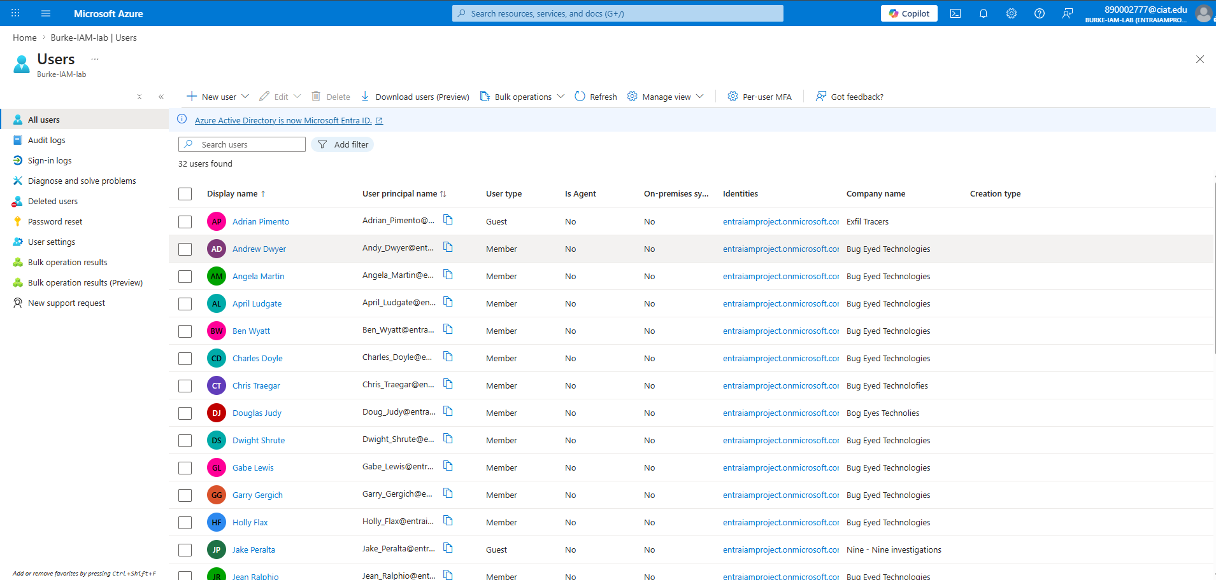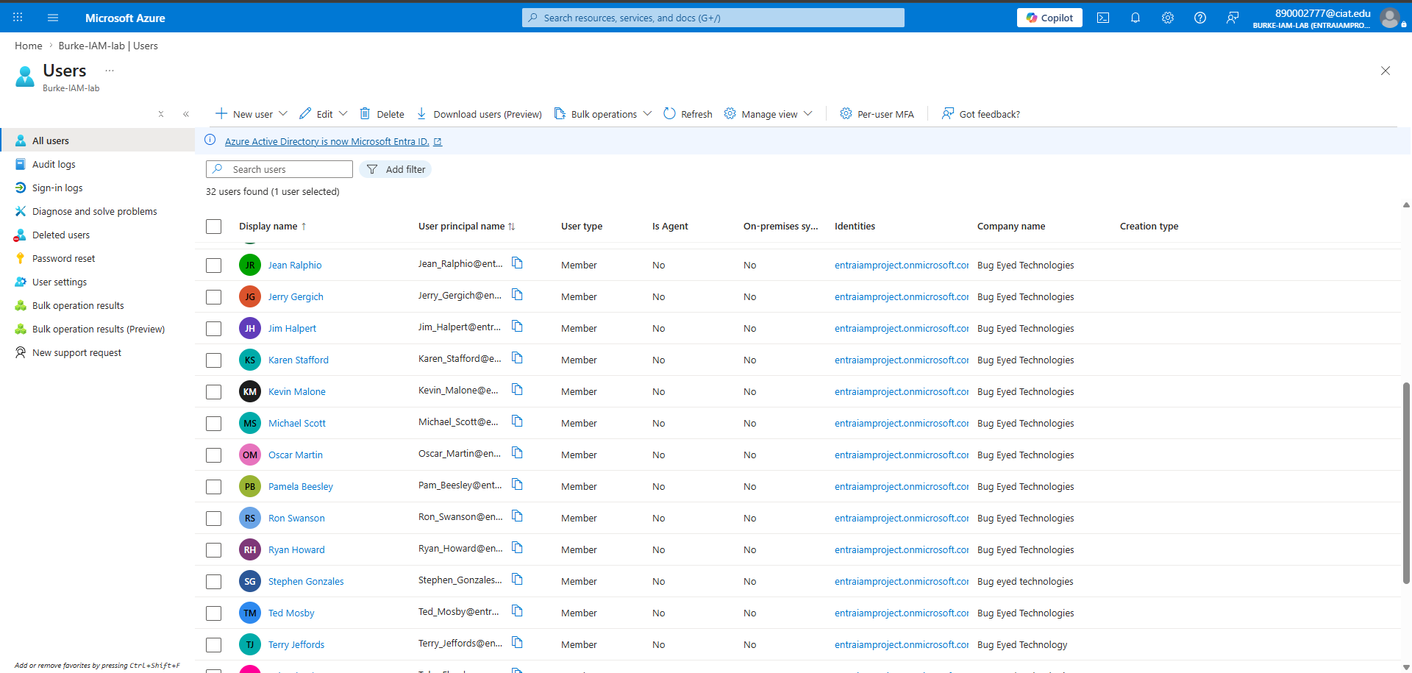
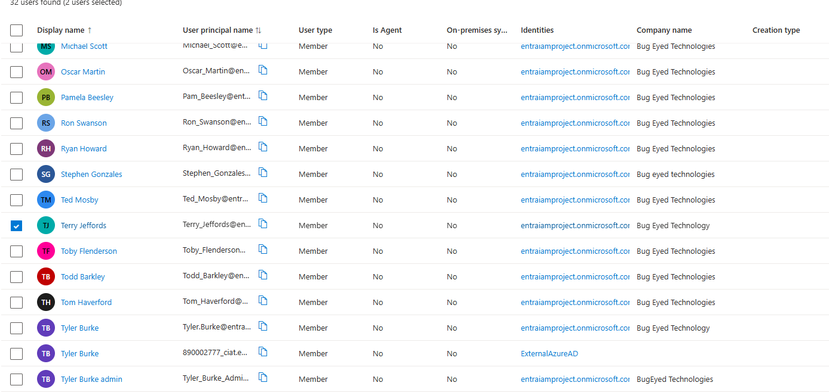

Groups:
The 13 groups represent the departments used in the enterprise environment.
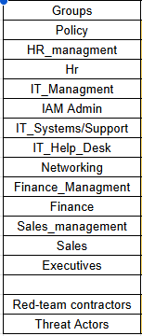
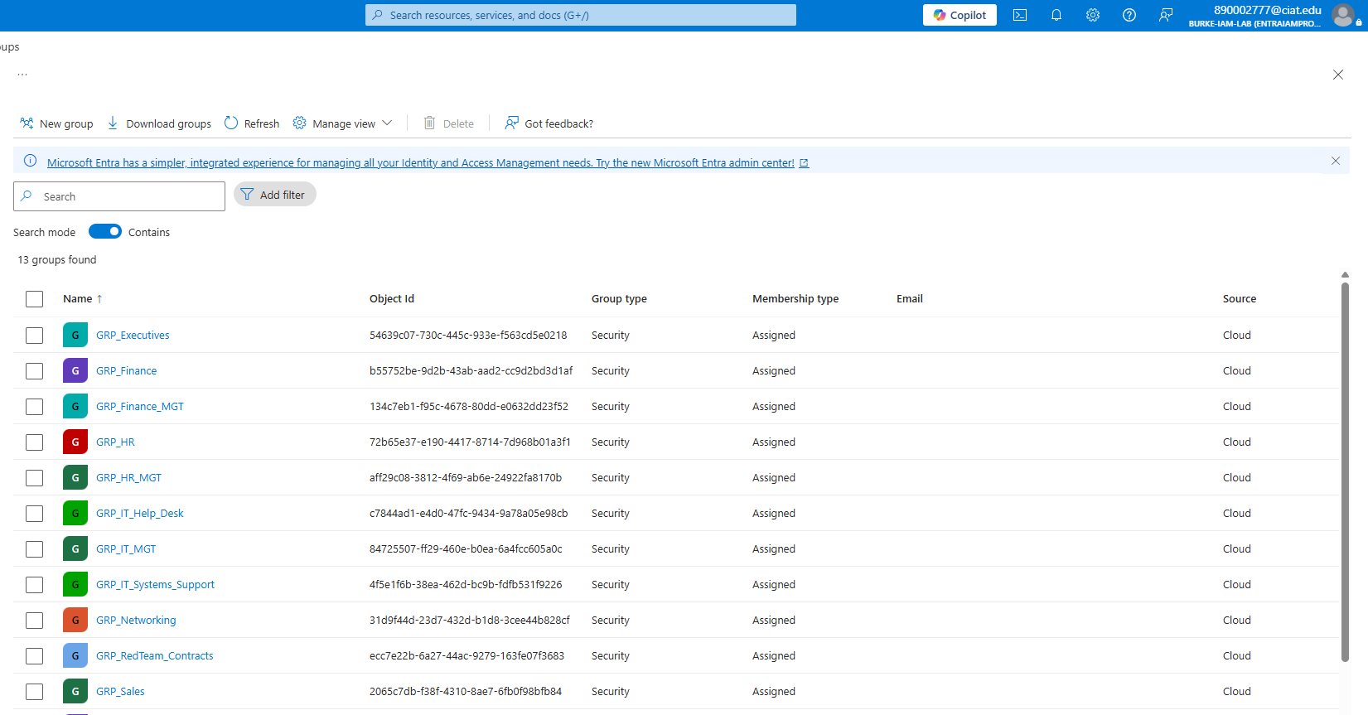

Users & Groups: In this section I mapped which user would belong to which group, the light blue colors represent the mixturew of multiple roles.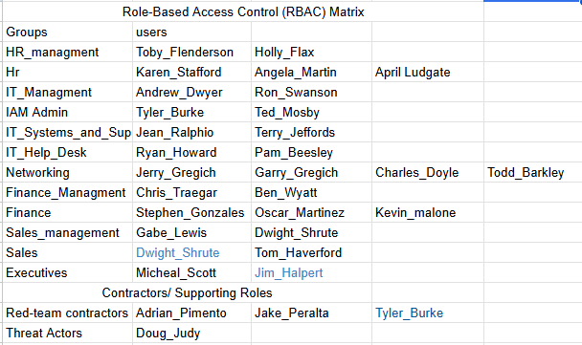
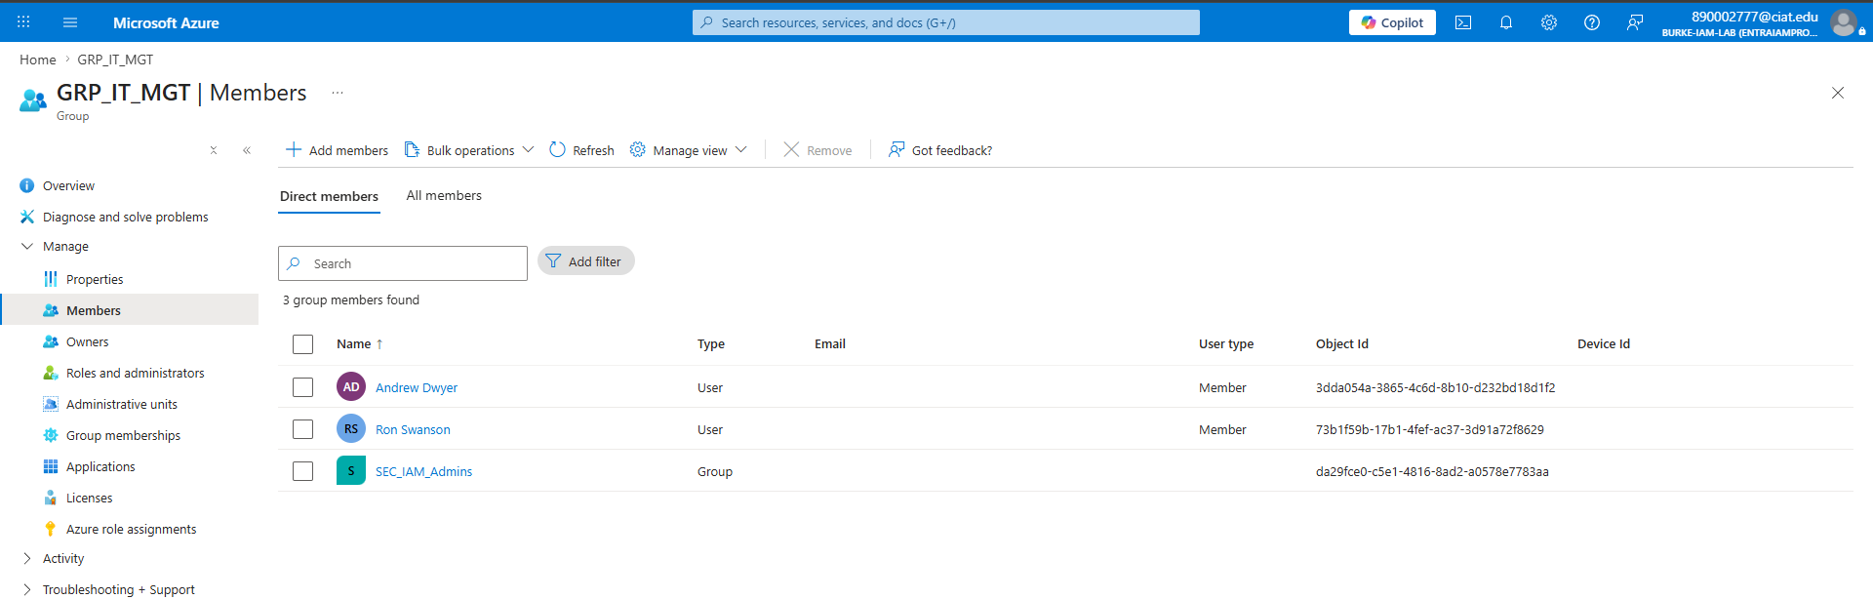
I implimented group nesting for the management teams to be nested int here respected departments as to show permissioning from grouping.
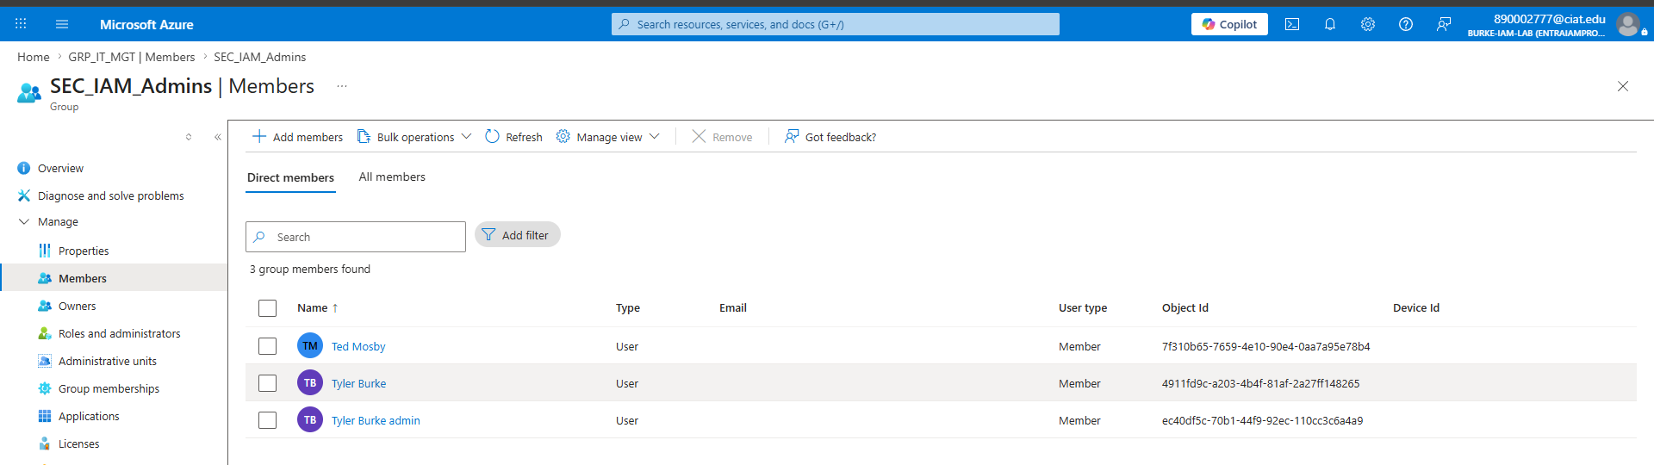

Groups & Applications with role permissions:
I was unable to assign the web applications to the roles and responsibilities due to limitations of entraId level.
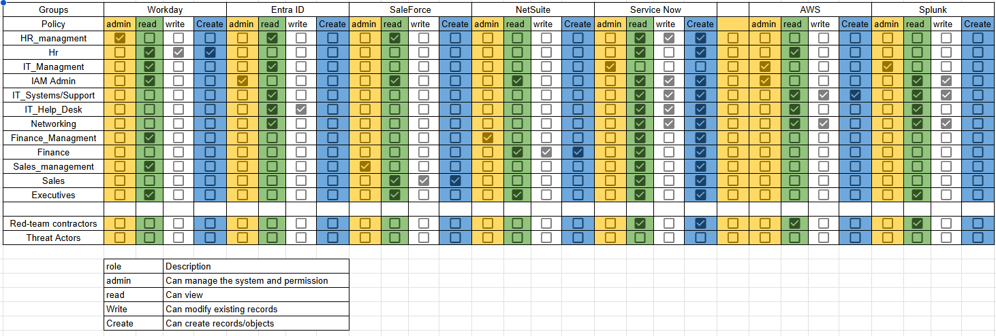

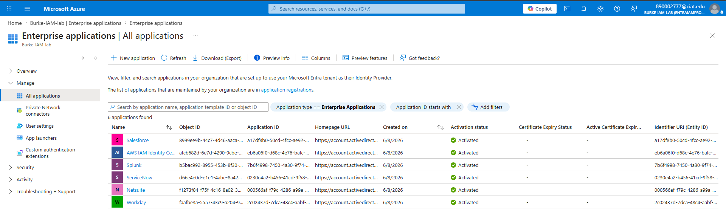
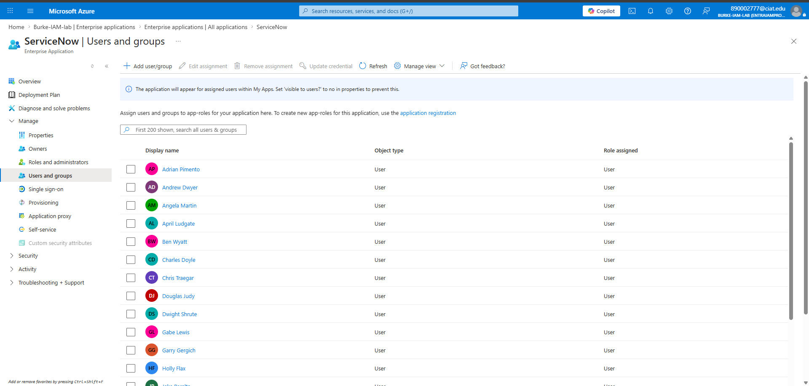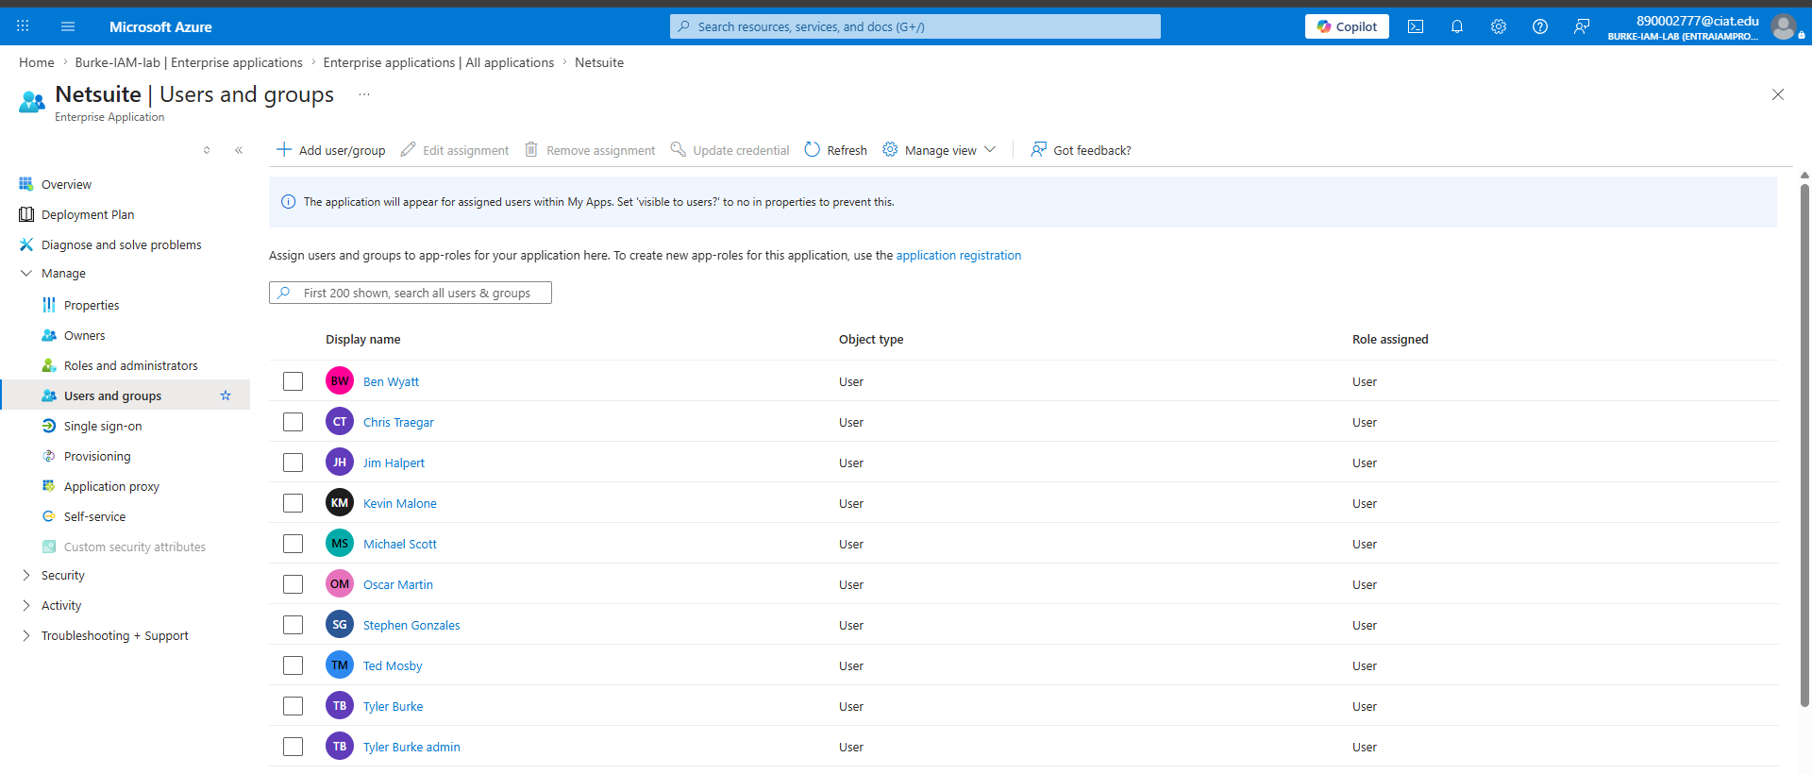

MFA:
Due to limitations of my EntraID account I cannot perform separate user accounts however I have the Security default active to force MFA on all privilege users
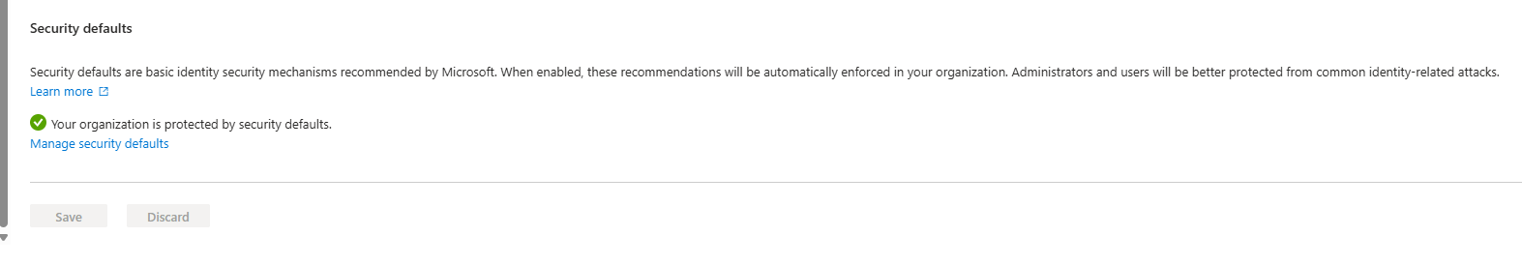

Lessons Learned:
This project provided practical experience with the design and implementation of an Identity and Access Management (IAM) environment using Microsoft Entra ID. Throughout the implementation process, several key IAM concepts were reinforced, including user lifecycle management, role-based access control (RBAC), group-based permission assignment, and enterprise application integration.
One of the most significant lessons learned was the importance of designing access around groups and roles rather than assigning permissions directly to users. This approach improves scalability, simplifies administration, and aligns with industry best practices for identity governance. The project also demonstrated how nested security groups can be used to create more flexible and maintainable access structures.
Working within the limitations of the available Entra ID licensing provided valuable insight into the differences between enterprise IAM design and platform-specific capabilities. While certain advanced features were unavailable, alternative solutions such as Security Defaults and group-based access assignments were successfully implemented to achieve the project's objectives.
The project also highlighted the importance of proper planning and documentation when managing identities, permissions, and application access. As the environment expanded beyond the original scope, maintaining clear relationships between users, groups, and applications became increasingly important.
Final Implementation Summary
During implementation, the environment evolved beyond the original project scope and resulted in:
- 32 user accounts
- 13 security groups
- 6 integrated enterprise applications
The environment included simulated SaaS and cloud-based platforms representing business functions such as Human Resources (HR), Customer Relationship Management (CRM), IT Service Management (ITSM), and cloud infrastructure administration.
This project successfully demonstrated core IAM principles including identity lifecycle management, RBAC design, group-based access control, application assignment, and multi-level group structures within Microsoft Entra ID. Despite licensing limitations, a structured and scalable identity model was designed, implemented, and documented with clear relationships between users, security groups, and application access permissions.
The completed environment serves as a foundation for Phase 2, which will extend identity management into AWS through federation with AWS IAM Identity Center, enabling a centralized multi-cloud identity and access management architecture.

Next Steps: AWS IAM Integration
The next phase of this project will focus on extending the identity architecture into Amazon Web Services (AWS) by integrating Microsoft Entra ID with AWS IAM Identity Center through SAML-based federation. This will enable centralized identity management, allowing users authenticated through Entra ID to securely access AWS resources without requiring separate AWS credentials. The implementation will include role-based access control (RBAC) using AWS IAM roles, user and group mapping between Entra ID and AWS, and the application of least-privilege access principles. This phase will demonstrate a multi-cloud identity management solution and provide hands-on experience with enterprise-grade identity federation and access governance across both Microsoft and AWS cloud platforms.

